**Create New Document sample application**

**CretaeNewDocument:** this is newly created sample app to create new document in HPRM via program using SDK API. In this user will select a document and instructs to save it in HPRM. Below are screenshots of application

1. Application UI as,

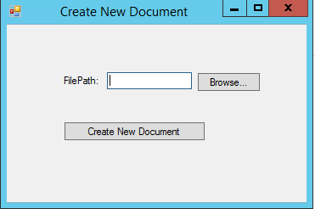

1. UI to select a file

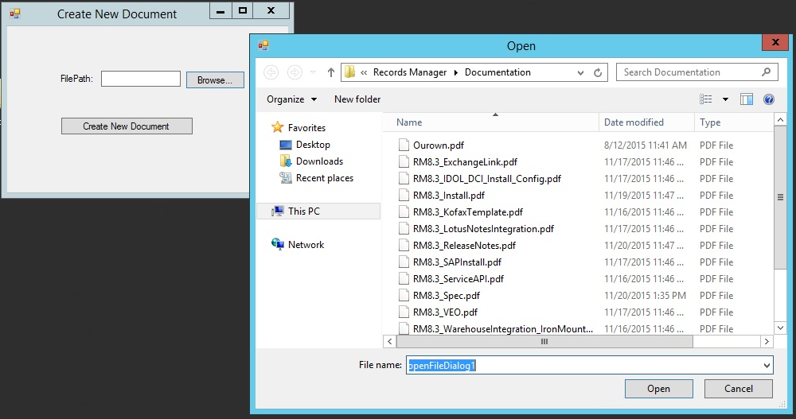

1. Showing Record Number after successful insertion in HPRM

